|  |  |
| --- | --- |
| Tuần: 24  Tiết: 47 | **REVISION** |

**\* Học sinh làm bài tập bên dưới để ôn tập chuẩn bị kiểm tra giữa HKII. Sau đó đối chiếu kết quả bên dưới.**

***I. Choose the word or phrase that best fits the blank space in each sentence.***

1. I’m disappointed _______________the result on my last exam. (that/ when/ if/ with)

2. We couldn’t go on a picnic as planned _____________________ it was raining hard.

(although/ but/ because/ so)

3. I suggest that you ____________work harder on your pronunciation .

(can, should, would, could)

4. Everyone must take part in _________________ deforestation.

(permitting, protecting, persuading, preventing)

5. My grandma’s eyes are weak, ___________________, she has to wear glasses.

(but/ however/ and/ therefore)

6. We should use ______________________________ to save energy.

(an energy- saving bulb/ an energy- save bulb/ a saving energy bulb/ a save- energy bulb)

7. If there is a mechanical problem, we suggest _______________the manufacturer directly.

(contact/ to contact/ contacting/ be contacted)

8. ________________want more information about the products they buy.

(Producers/ Sellers/ Manufacturers/ Consumers)

9. Electricity, gas, and water are not luxuries but _______________________ .

(necessities/ wonderful/ cheap/ enormous)

10. I think we should turn off the faucet. - ________________________________

(No, thanks/ That’s a good idea/ I’m sure/ Not at all)

11. What advice do you give him?

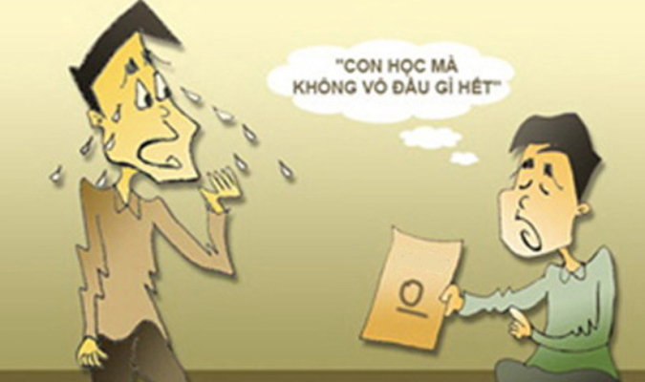

*I get bad mark*

A. you should go to bed early B. You should give me the test

C. You should play sports D. You should study harder

|  |  |
| --- | --- |
|  | **12.** What does this sign mean?  A. Reducing  B. Recycling  C. Reusing  D. Reacting |

**II. Complete the passage with the words in the box .**

|  |
| --- |
| **resources same consumers machines will labeling how** |

“ In Europe, there is a **(27)____________________**scheme for refrigerators, freezers, washing (28**)____________________** and tumble dryers. The label tells the consumers (29**)________________** much energy efficiency each model has, compared with other appliances in the **(30)______________** category.

Ultimately, these innovations (31**)___________________** save money as conserve the Earth’s (**32)_________________”**

**\* KEYS:**

***I. Choose the word or phrase that best fits the blank space in each sentence.***

1. with

2. because

3. should

4. preventing

5. therefore

6. an energy- saving bulb

7. contacting

8. Consumers

9. necessities

10. That’s a good idea

11. D

12. B

**II. Complete the passage with the words in the box .**

13. labeling

14. machines

15. how

16. same

17. will

18. resources

**THE END!**

|  |  |
| --- | --- |
| Tuần: 24  Tiết: 48 | **REVISION** |

**\* Học sinh làm bài tập bên dưới để ôn tập chuẩn bị kiểm tra giữa HKII. Sau đó đối chiếu kết quả bên dưới.**

***I. Read the passage carefully*** :

Nowadays, many families are worried about their water bills. Some of the bills are enormous. In fact, they can save their money if they try to reduce the amount of water their families use. There are some easy ways to do this. First, get a plumber to make sure there are no cracks in the pipes. Second, do not use baths because they use twice as much water as showers; take showers instead. And last but not least, remember to turn off the faucets since a dripping faucet can waste up to 500 liters of water a month. By doing these things, we can both save our own money and save water for future generations.

**True or False ?**

1. Some families pay a lot of money for their water use.

2. A plumber checks if people in the family take showers.

3. Dripping faucets contribute to the waste of water.

4. Future generations will not need to use water.

**II. Use the orrect form of the word given in each sentence.**

5. There are a lot of technological _________________ designed to save energy. (innovate)

6. We find advertising on TV very _____________________. (effect)

7. Nam has ________________ borrowed me his book. (kind)

8. Energy – saving bulbs help __________________ save money. (consume)

9. _______________ air can make people fall ill. (pollute)

10. We should ________________ the amount of water your family uses. (reduction)

**III. Put the words or phrases in correct order to make sentences.**

11. learn how/ unpolluted/ to protect/ people should/ our environment/.

People should __________________________________________

12. to save electricity / people/ energy- saving bulbs / should use/ .

🡪 People _________________________________________________________ .

I**V. Rewrite the following sentences so that they stay the same as the first.**

13. Why don’t you check your teeth regularly, Loan?

Mrs. Hoa suggested that Loan ____________________________________

14. Unless he gets a visa, he can’t go abroad.

He can’t ______________________________________

15. Lan didn’t do her homework, so she was punished .

Because ______________________________________

16. Study hard or you will fail the final exam.

If ________________________________________.

17. Nam works very carefully.

Nam is _____________________________.

**THE END!**

**\* KEYS:**

**I. True or False?**

1. True

2. False

3. True

4. False

**II. Use the orrect form of the word given in each sentence.**

5. innovations

6. effective

7. kindly

8. consumers

9. Polluted

10. reduce

**III. Put the words or phrases in correct order to make sentences.**

11. People should learn how to protect our environment unpolluted.

12. People should use energy – saving bulbs to save electricity.

**IV. Rewrite the following sentences so that they stay the same as the first.**

13. Mrs. Hoa suggested that Loan should chech her teeth regularly.

14. He can’t go abroad if he doesn’t get a visa.

15. Because Lan didn’t do her homework, she was punished.

16. If you study hard, you will fail the final exam.

17. Nam is a very careful worker.

**THE END!**